TELEGRAM BOT PROJECT WITH PYTHON

PROJECT REPORT

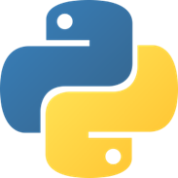

This document has been prepared to explain how to create a Telegram bot from scratch for the Windows operating system using the Python programming language.

1. Installing Python:

Python is downloaded and installed from the link marked in red at <https://www.python.org/downloads/> .

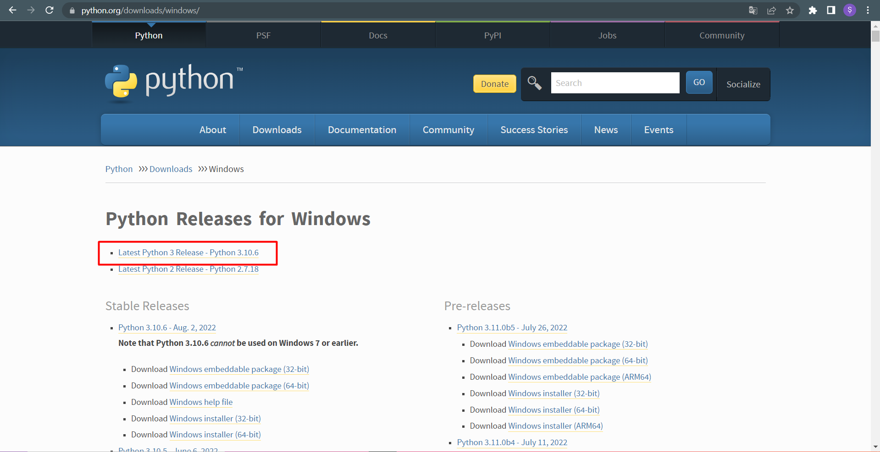

1. Installing Anaconda:

Various IDEs can be used to program with Python. Spyder was used in this project and Anaconda, an integrated Python distribution system, was used to use this interface. Go to the following screen from [https://www.anaconda.com/products/distribution](https://www.anaconda.com/products/distribution%20) address and download and install Anaconda from the button marked with red on the screen.

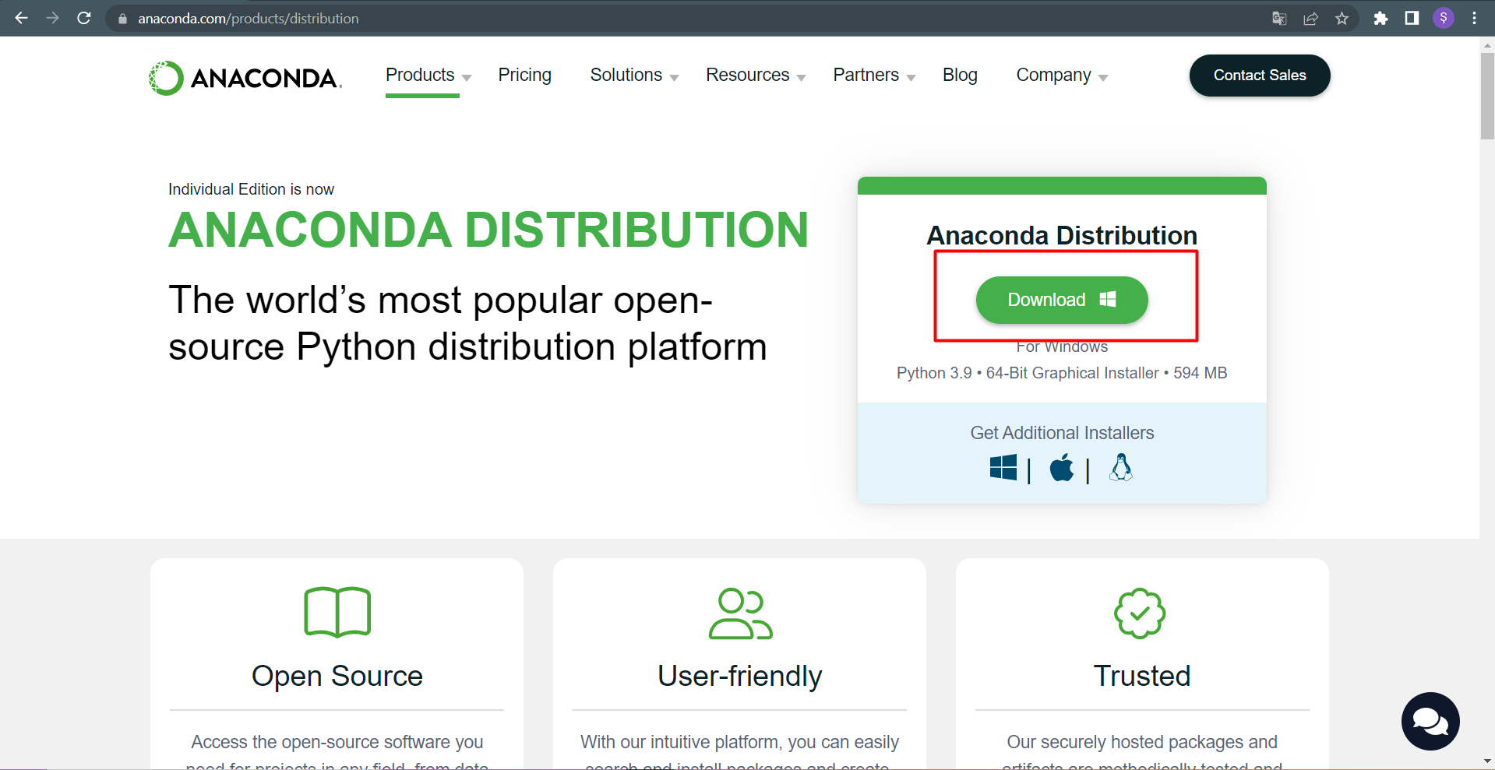

-After the Anaconda installation, the following screen will appear and Spyder will be used as shown below.

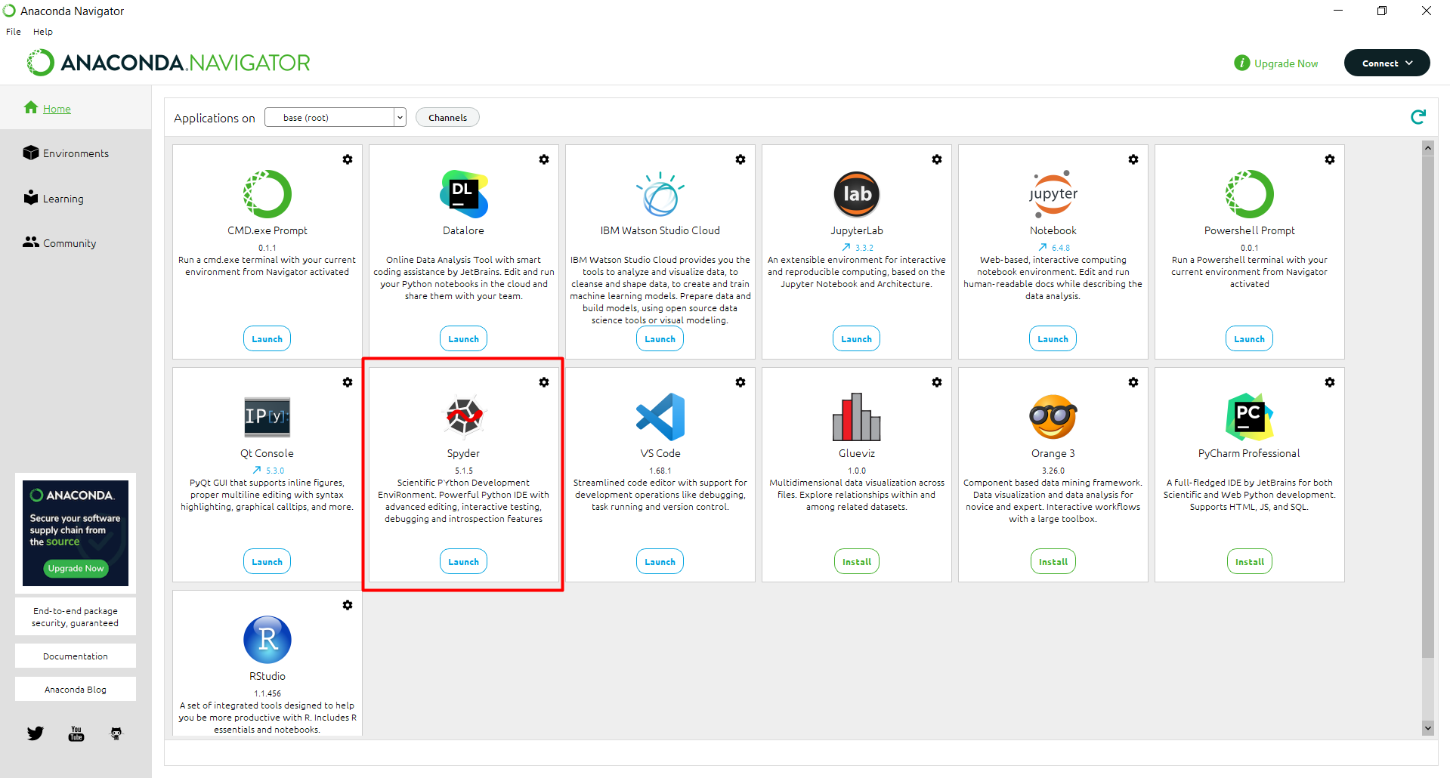

1. Installing ***python-telegram-bot*** library:

This library provides a pure Python interface for the Telegram Bot API. In addition to its pure API implementation, it has a number of high-level classes to make the development of bots easy and straightforward. These classes are located in the ***telegram.ext*** submodule.

To install the ***python-telegram-bot library***, after opening the command prompt on the computer: ***pip install python-telegram-bot*** command should be run.

metin içeren bir resim

Açıklama otomatik olarak oluşturuldu

- In some cases, the ***pip install python-telegram-bot*** command may not work. In this case, the following operations should be performed in order at the command prompt. (Git must be installed on the working computer in order to perform the operation described below. It can be downloaded from <https://git-scm.com/download/win>.)

- ***git clone https://github.com/python-telegram-bot/python-telegram-bot***command is typed.

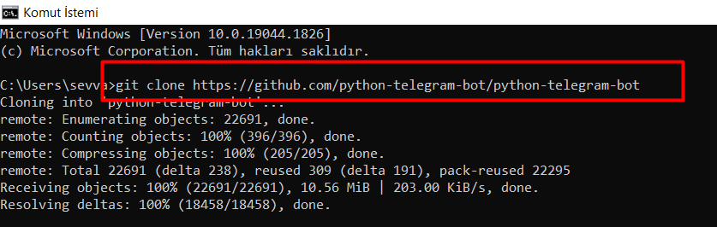

-Then ***cd python-telegram-bot*** and ***python setup.py install*** commands are typed and run respectively. This completes the library installation.

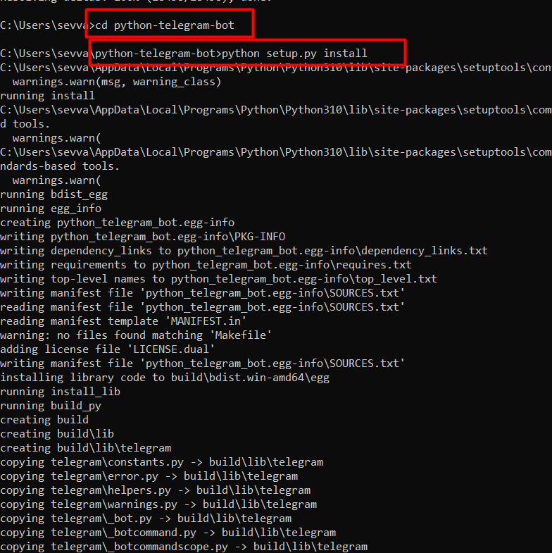

1. Adım- BotFather’dan yeni bot oluşturmak:

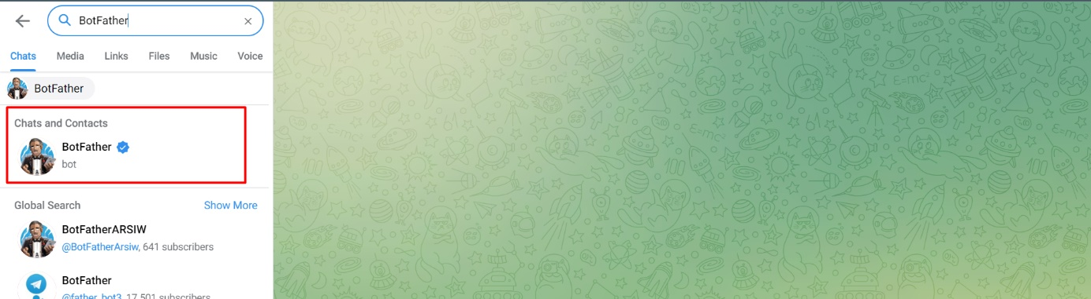To create our own bot on Telegram, BotFather, a bot belonging to Telegram, is assisted. By entering the Telegram application, BotFather is typed in the search section and started with the ***/start*** command.

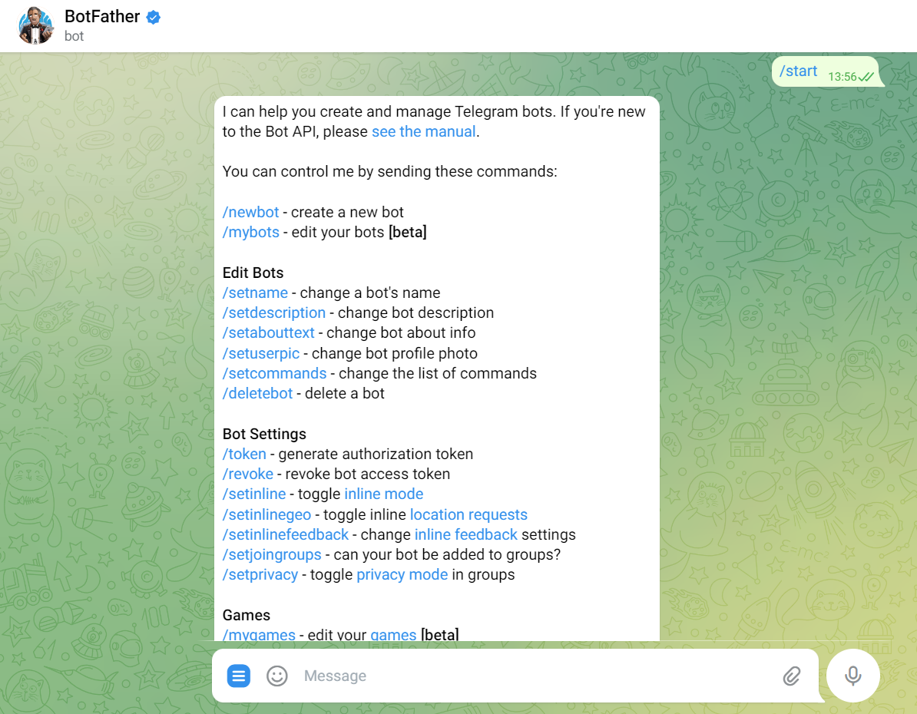

- The request to create a new bot is said with the ***/newbot*** command, then a name and username are determined for the bot to be created and sent to BotFather. In return, BotFather issues a token. This token should be stored and not shared because it is actually a password that can manage the bot.

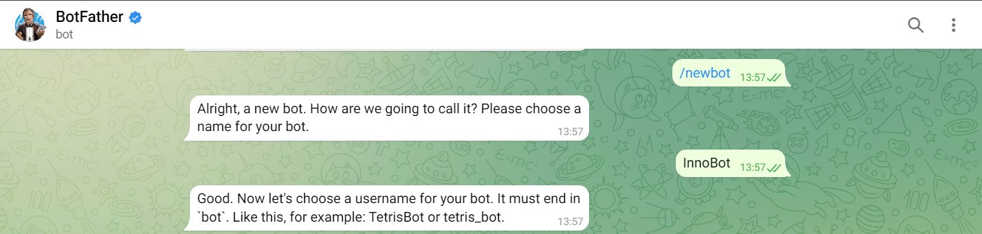

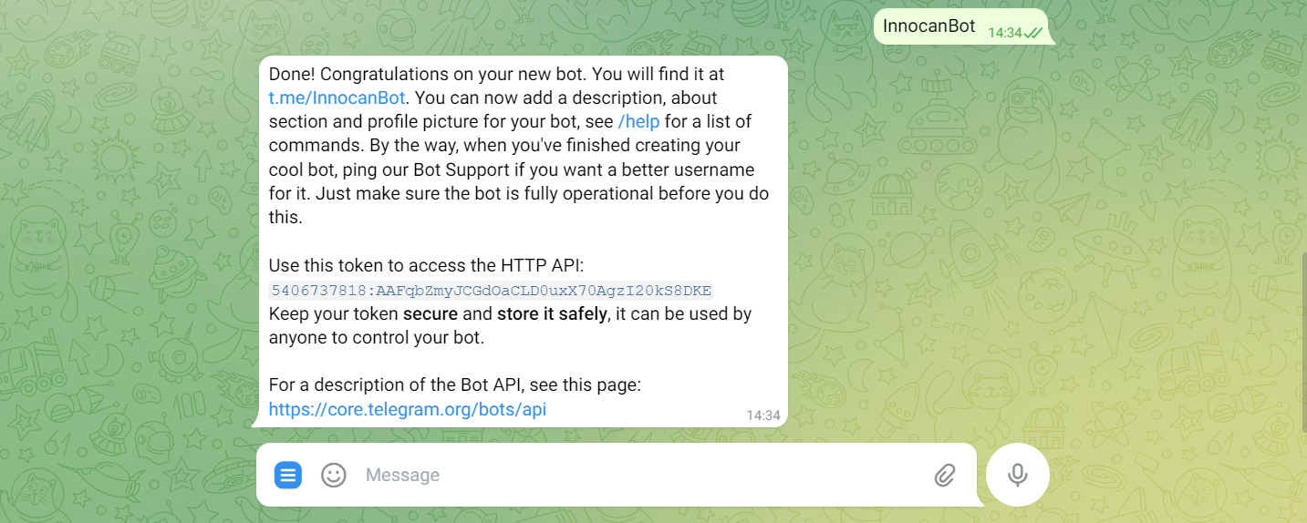

- With the -/setuserpic command, a profile photo is determined for the bot.

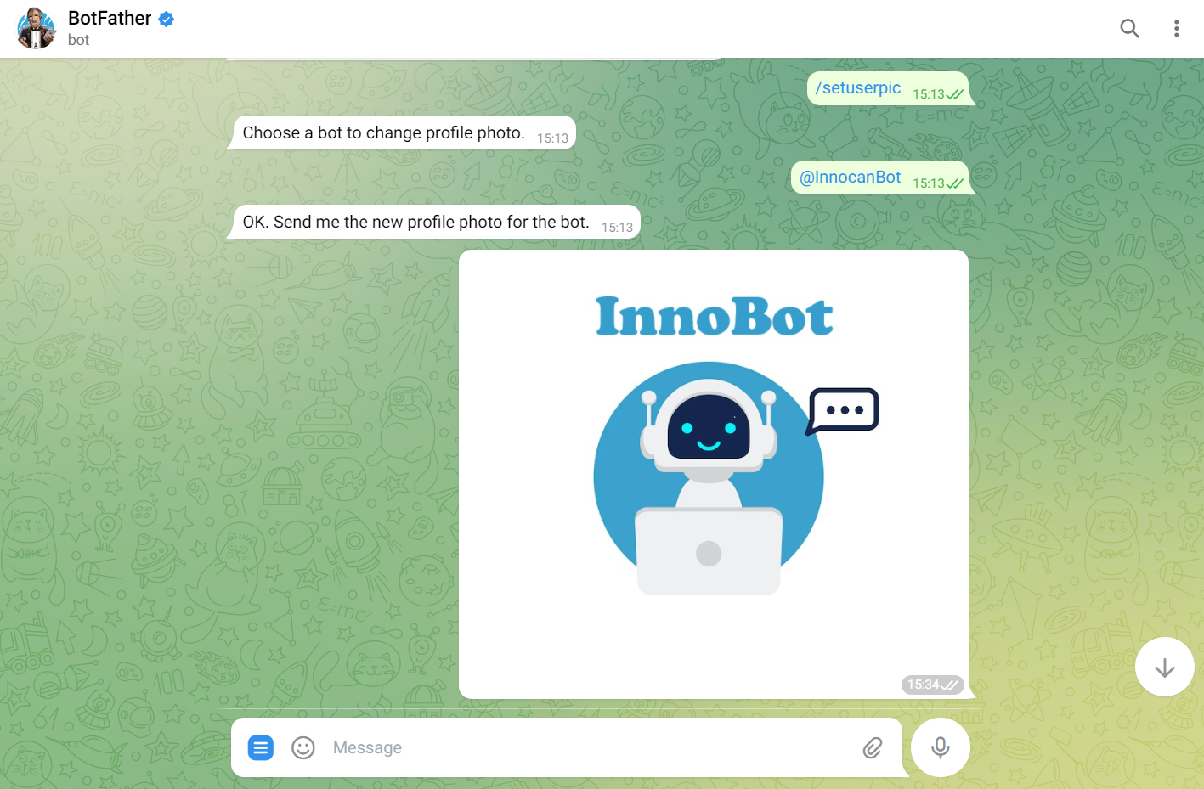

1. Adım- Telegram botu ile Python’ın entegre edilmesi:

The Spyder interface downloaded in step 2 is opened and a ***main()*** function is created, the token from BotFather is written into it, and the relationship between the codes written in Python and the Telegram bot is established. Thus, commands can be defined to the bot in Python, and it can be viewed whether these commands are executed in the Telegram application.

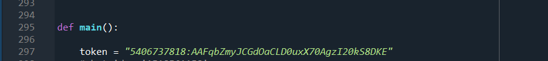

1. Shaping the code according to the needs:

metin içeren bir resim

Açıklama otomatik olarak oluşturulduThe code can be shaped according to the desired needs. The simplest version of the code has been added below. When the token of the created bot is added to this code and run, the bot will only understand the ***/start*** command and will say "Merhaba!" (hello).